Physical Electronics –
Minority Carriers

By: David Clarke
Course: Electrical & Electronic Engineering2
Date:24/3/2000

Abstract

It can be shown that through a systematic approach, the behaviour of minority carriers in a bar of a semiconductor can be described. To enable the experimenter to get a full understanding of this Haynes-Schottky experiment a number of measurements must be taken. Once the mobility, lifetime and diffusion constant is known, then the overall behaviour for the minority carriers (in this case holes) is known. These fundamental discrepancies are illustrated in semiconductor theory, this semiconductor theory is used by the graphical and tabular experimental results as proof. The relationships between theory and experimental data is illustrated in the results section.

Introduction

In the classic Haynes – Schottky experiment a bar of a semiconductor has ohmic contacts at either end and along its length are two rectifying contacts or pn junctions. An electric field is established along the bar and minority carriers are injected at one diode and drift in the direction in the direction of the second diode. The latter junction is reverse biased and as the injected minority carriers drift past it, some are collected, (in the same way that the collector functions in a transistor) and a current flows in the junction. If the dimensions of the sample and the drift time are measured, then the minority carrier drift mobility can be calculated. The effects of diffusion are apparent in the experiment and the diffusion constant can be calculated using the Einstein relation. It is also possible to estimate the lifetime of the excess minority carriers by measuring the variation in the number of minority carriers collected with drift time.

- Principles of Methods

1). Pulse the voltage across the silicon sample (else the sample becomes very hot and will be destroyed) and if the duty cycle is small there is little heating. A pulse width of about 4 μs and a pulse period of about 100 μs is okay. Do not exceed 5V until you are sure that a low duty cycle is established.
mA
PG
A1
E
C1-4
A2
470Ω
10KΩ
9V
Drift
Time

[Figure .1.]

2). To measure the mobility as outlined, the transit time is measured from the start of the pulse from the pulse generator to the centre of the minority carrier pulse. Select a single collector and use approximately a 10V pulse from A₁ to A₂.

3) If the experiment were carried out using a rectangular or uniform sectioned sample of silicon the electric field in the device would be uniform. We cannot assume this however. We need to measure a correction factor by which to multiply the apparent electric field. All that is necessary to put a known value pulse across the device (A₁ – A₂) and measure the potential difference between E and C₄ as indicated in Figure 3 and Figure 1. The silicon chip will just behave as a resistor. The problem is that you cannot measure the potential at E and C₄ because the diodes are reverse biased, so use the spare device and put a negative (-10 Volts) pulse across the sample. The diodes are now forward biased.

4) To Estimate the carrier lifetime. You need to measure the change in minority carrier density with time. One way to do this is to select say – C1 and set the emitter current so that as the applied voltage is changed the time and number of collected carriers changes. You can estimate the number of collected carriers by estimating the area of the collected pulse. Now plot a graph of Ln (Area) versus time. You must not change the emitter current during this measurement. Alternatively keep the voltage constant and use the four collectors to change the time.

Results

CALCULATION OF THE CORRECTION FACTOR

Amplitude of the pulsed voltage V = 10 V
Length of Silicon sample L = 950 um

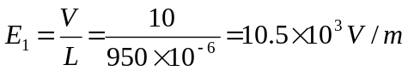

At 450um the potential of the sample with respect to ground equalled 4V

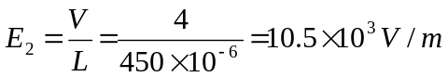

Hence the correction factor is:

Correction factor = 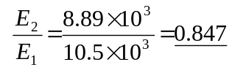

CALCULATION OF THE MINORITY CARRIER MOBILITY

Using Method 2

Rearrange the theory equation and plot a graph of “d” against “t” for a constant voltage pulse varying “d” by using the four collectors. Hence find the mobility.

Distance from E to C1, C2, C3, C4 = 225, 300, 375μm respectively.

Instead of approaching the calculation of mobility in a graphical sense, a tabular approach has been adopted. To calculate the velocity of the minority carriers for each emitter current, the time taken for the minority carriers to reach each of the collectors (from the emitter) in conjunction with the relative distances between the emitter and collectors (shown above) is used. These four velocities (well three in the case of this experimental data) are then averaged to give the average value of the minority carrier velocity for each emitter current. From these individual average velocities the mobility of the minority carriers can be calculated using the method shown below.
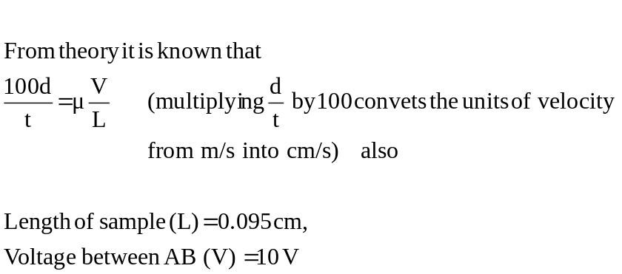
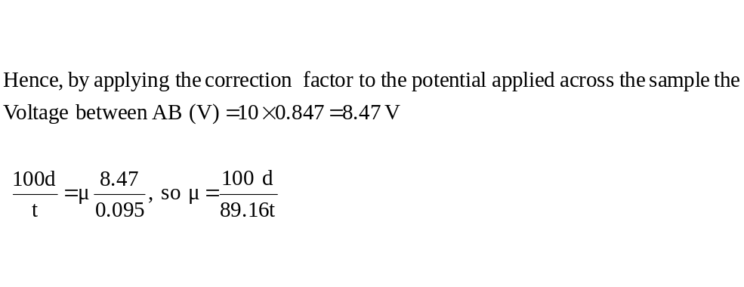

Emitter  Current (mA) | Collector  C1 | Collector  C2 | Collector  C3 | Collector  C4 | Average  Velocity  d/t (m/s) | Mobility  1.12d/t  cm²/Vs
0.9 | 9.5E-7 | 1.25E-6 | 1.48E-6 | - | 243.40 | 272.61
0.7 | 9.25E-7 | 1.23E-6 | 1.45E-6 | - | 248.59 | 278.42
0.5 | 8.75E-7 | 1.18E-6 | 1.38E-6 | - | 261.04 | 292.36
0.3 | 8.25E-7 | 1.1E-6 | 1.28E-6 | - | 279.47 | 313.01
0.1 | 7.5E-7 | 0.98E-6 | - | - | 303.06 | 339.43
[Table .1.]

From these mobility values a distinct relationship between emitter current and the mobility can be seen.

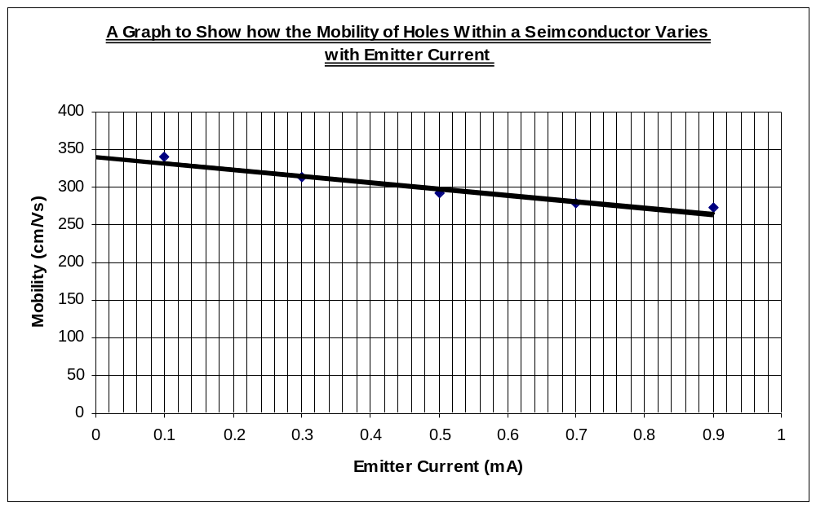[Graph .1.]

CALCULATION OF THE DIFFUSION COEFFICIENT

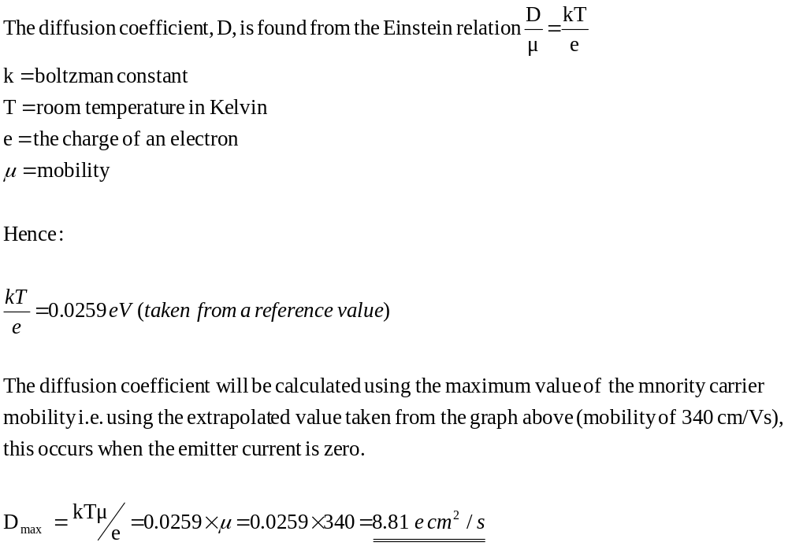

CALCULATION OF THE LIFETIME

The emitter current was kept constant at 1.0mA, by using collector C1 and varying the pulsed voltage from 12 – 6V the various pulsed waveforms were collected. For each waveforms their areas were estimated and recorded below.

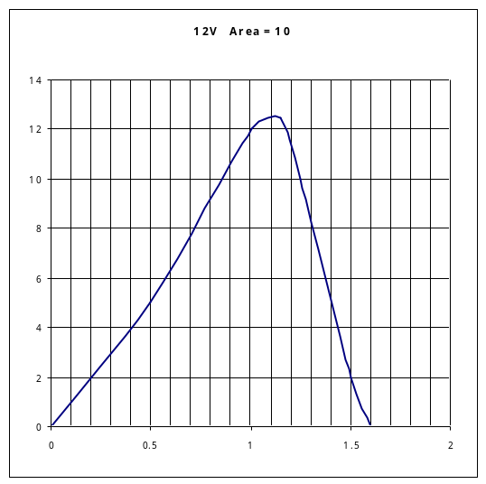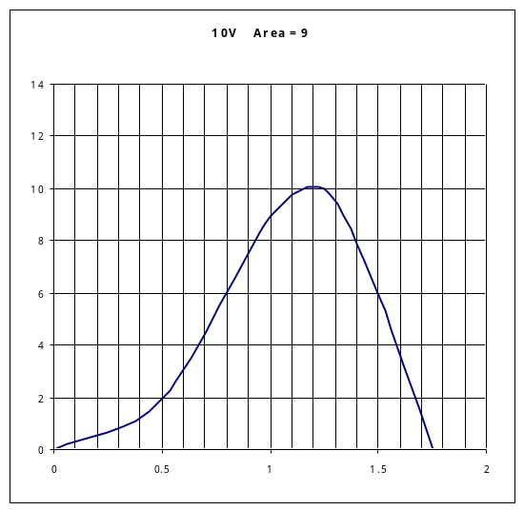
[Graph .2.] Pulsed Voltage Used = 12V [Graph .3.] Pulsed Voltage Used = 10V
Area = 10 V/s Area = 9 V/s

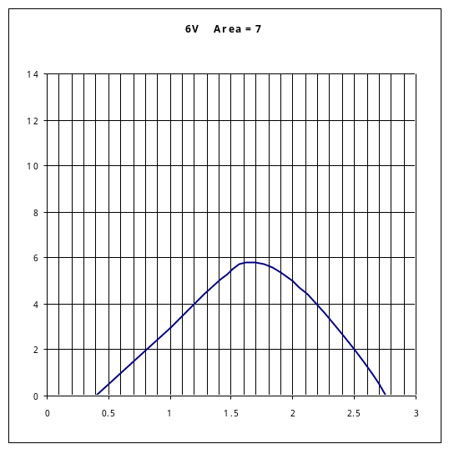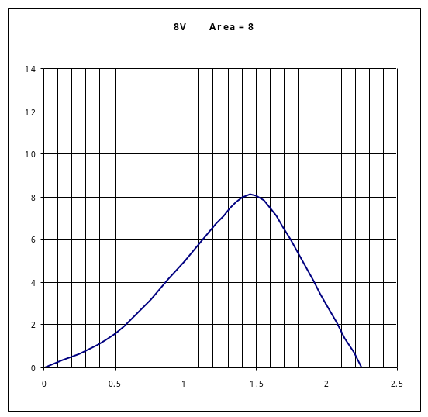
[Graph .4.] Pulsed Voltage Used = 12V [Graph .5.] Pulsed Voltage Used = 10V
Area = 8 V/s Area = 7 V/s

In the table below, the natural log of the area (the number of collected carriers) is calculated for each pulsed Voltage value. The drift time (t) value is taken straight from the graphical data, i.e. The time at which the maximum minority carrier collection current flows through the resistor attached to Collector C1.

Pulsed Voltage (V) | Area (V/s) | ln Area | t (us)
12 | 10 | 2.3 | 1.15
10 | 9 | 2.2 | 1.25
8 | 8 | 2.08 | 1.4
6 | 7 | 1.95 | 1.6
[Table .2.]

By plotting a graph of the drift time versus the natural log of the area the Life time of the sample of minority carriers can be calculated.

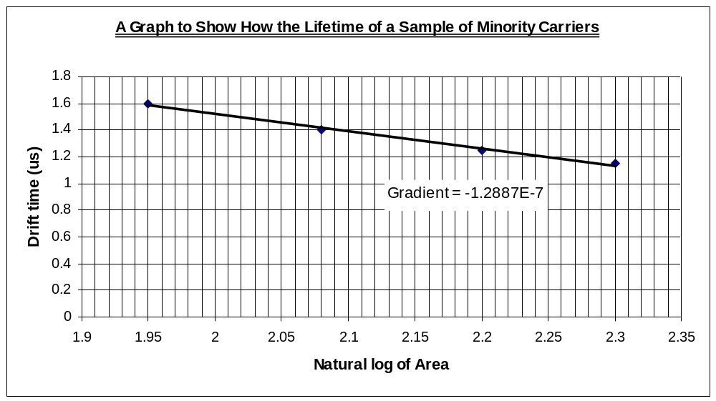
[Graph .6.]

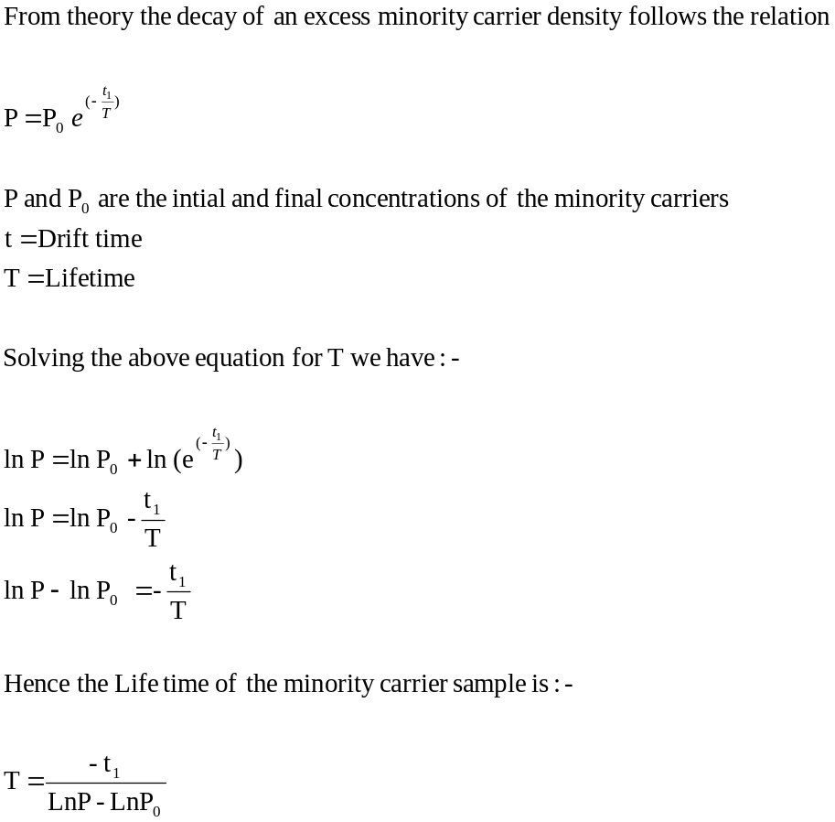

The gradient of the graph.6. is exactly what that equation represents i.e. The drift time over an initial and final concentration of holes, the negative sign indicates the direction of the slope.

Hence from the slope:

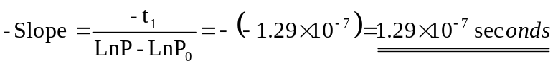

- Discussion of Results and Conclusion

GENERAL OBSERVATIONS

Turn up the emitter current, why does the carrier transit time seem to increase?

There are a lot more minority carriers (holes) produced at the emitter. Hence these holes populate a more widely dispersed area around the emitter. Hence the distance required for the average minority carrier to travel has increased, plus, with a greater number of minority carriers there are a greater number of collisions between neighbouring charges which will in effect increase the transit time.

Why does the pulse become relatively wider for larger transit times?

When larger transit times are faced by the minority carriers dispersion occurs due to the non-uniform electric field and recombination of holes in the n type semiconductor region. Hence what can be seen at the collector is a pulse with a wider base but lower peak voltage, compared to a waveform of lower transit time origin. These results are illustrated in graphs 2 – 5 of the lifetime calculation.

OTHER OBSERVATIONS

1). The book value of mobility, the mobility of the minority carriers when the Haynes-Schottky experiment was undertaken = 480 cm²/Vs. For what value of emitter current is unknown. Looking at the experimental data in table 1, the avarage mobility of the minority carriers (for an emitter current in the range of 0.1 – 0.9 mA) is around 300 cm²/Vs. Comparing the average experimental value with this book value, the experimental value is of similar magnitude differing by 180 cm²/Vs. In this experimental setup a mobility of 480 cm²/Vs would not be achievable. The original Haynes-Schottky experiment was carried out under different conditions with different aparatus (the doped silicon they used was straight and uniform, the semiconductor used in this experiment is circular), hence this reference value can not be taken into consideration.

2). Referring to graph 1 on page 5, as the emitter current is decreased from a high emitter current 0.9mA towards 0mA notice the distinct linear relationship between emitter current and mobility. The gradient of the slope is negative indicating an inverse proportionality between the increases in mobility current against the increase in emitter current. This relationship can be easily explained using a diagram.
E
C1
A1
A2
Electric
Field
Holes
[Figure.2.]

When a lot of holes are produced at the emitter (high level of current), once influenced by an electric field the holes move towards A2. Not all the holes are influenced in exactly the same manner due to the electric field being non-uniform, and the potential is different along the sample. By these phenomena and many more, collisions between neighbouring holes occur. Hence the average mobility and the velocities (mobility = 1.12 v_{ave}) of the holes will be lower which gives rise to an increase in the drift time from the emitter to collector. Holes with no neighbours in front of them (between them and the collector) will then have the higher mobility due to no chance of a collision occurring. While the holes at the back of the bunch (furthest away from the collector) should have the lowest mobility due to the greater probability of a collision between neighbouring holes occurring.

3). The diffusion coefficient, D, found from the Einstein relation is only valid at a specific emitter current. Hence can be said to be constant at a constant emitter current. When working at for example 1 mA there is a corresponding diffusion coefficient at that value. The mobility can then be calculated because the other terms k,T and e are constant at room temperature.

4). The value for the lifetime of the minority carriers (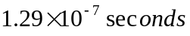) is a good experimental result, this is in comparison to the book value of 0.1 microseconds. A very small value it may be, but very small distances are used between emitter and collector, and under the influence of a magnetic field the holes move at high velocities. The result tells us that the minority carriers (the holes) will recombine in the semiconductor after 0.129 microseconds when an emitter current of 1.0 mA is used. Because the lifetime of the holes is concentration dependent, there is a different minority carrier lifetime for different emitter currents. This is analogous to a block of is ice at room temperature, a larger block of ice will take a longer time to melt than one of smaller size.

References

i). D.E Gray, ‘Writing a technical paper’, Physics Education, 1967, Vol.2, p.81-88

ii). Physical Electronics, experimental paper, p.1 - 4

